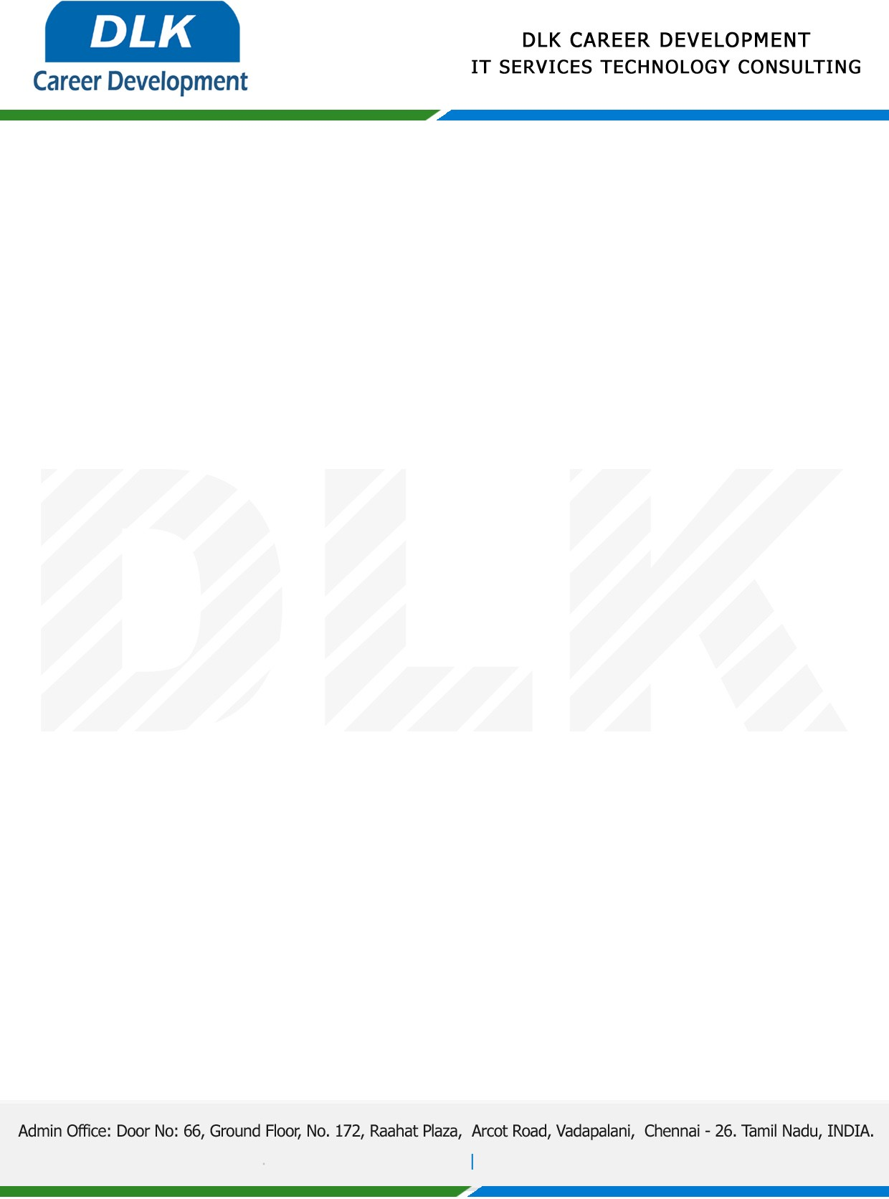

**Date: 20/ April /2023**

**SUB: PROJECT COMPLETION CERTIFICATE**

This is to certify that **MR MOHAN S (REG NO:** **21Msc037) MSC- Computer Science,** final year student **Hindustan College of Arts and Science,Chennai** has Successfully Completed the Project Work under the domain of “**Java”** in our organization during the Period **(20th February 2023 to 20th April 2023).**

**Topic:** Proxy Re-Encryption for Secure Medical Data Sharing**.**

We appreciate your interest in **DLK CAREER DEVELOPMENT**

**“Best Wishes for Your Future Endeavors “**

